8-Band Vehicle-Mounted FPV Drone Jammer - Specification

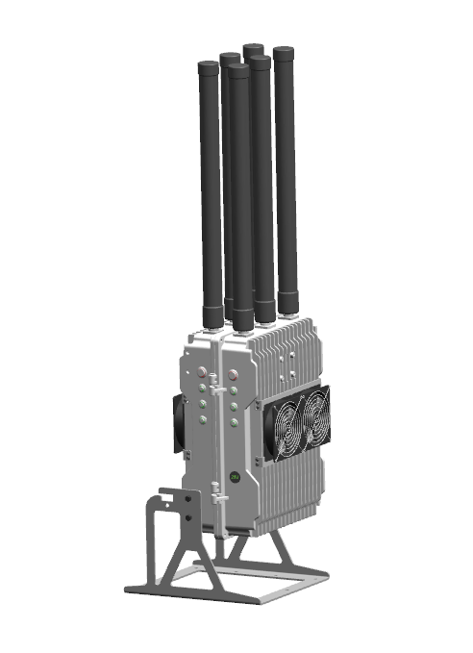
Model No: TTSKF04
- Product Features
- High-power portable jammer
- Quick deployment on site, easy assembly and
disassembly, fast vehicle installation
- Independent modular design for convenient
service, maintenance, and upgrade
- Fully cast aluminum chassis design for excellent
heat dissipation and stable system performance

Technical Specifications
Specification | Details
Frequency Bands | 433Mhz/700Mhz/900Mhz/1.2Ghz/1.5Ghz/2.4hmz/5.2Ghz/5.8Ghz
Total RF Output Power | Up to 400W
Number of Jamming Modules | 8 (50W per module)
Cooling System | Dual-fan cooling system
Jamming Source | Analog signal synthesis technology
Antenna Type | Omnidirectional fiberglass antennas
Number of Antennas | 8
Power Supply | DC 24-28V
Device Dimensions | 42 x 24 x 22 cm
System Weight | Approx. 8.5 kg (including antennas)
Operating Temperature | -35°C ~ +80°C
IP Rating | IP67
Power Connector | Equipped with 24V cigarette lighter plug

Main Unit View
